**High Performance Computing Lab**

**Practical No. 7**

**Title of practical:**

Installation of MPI & Implementation of basic functions of MPI

**Problem Statement 1:**

Implement a simple hello world program by setting number of processes equal to 10

CODE :

#include <mpi.h>

#include <stdio.h>

int main(int argc, char** argv) {

MPI_Init(&argc, &argv);

int world_size;

MPI_Comm_size(MPI_COMM_WORLD, &world_size);

int world_rank;

MPI_Comm_rank(MPI_COMM_WORLD, &world_rank);

printf("Hello, World! I am process %d of %d.\n", world_rank, world_size);

MPI_Finalize();

return 0;

}

**Screenshots:**

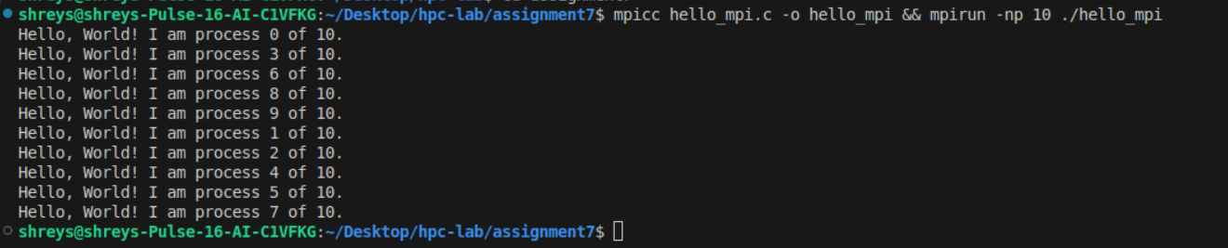

**Problem Statement 2:**

Implement a program to display rank and communicator group of five processes

CODE :

#include <mpi.h>

#include <stdio.h>

int main(int argc, char** argv) {

MPI_Init(&argc, &argv);

int world_size;

MPI_Comm_size(MPI_COMM_WORLD, &world_size);

int world_rank;

MPI_Comm_rank(MPI_COMM_WORLD, &world_rank);

printf("Hello, World! I am process %d of %d.\n", world_rank, world_size);

MPI_Finalize();

return 0;

}

**Screenshots:**

